

Faculty of Engineering andTechnology

#### Department of Electronics and Communication Engineering

Jain Global Campus, Kanakapura Taluk - 562112 Ramanagara District, Karnataka, India

**2016-2020**

**A Project Report on**

**“DETECTION OF ADULTERANTS IN MILK”**

**Submitted in partial fulfillment for the award of the degree of**

**BACHELOR OF TECHNOLOGY IN**

### ELECTRONICS AND COMMUNICATION ENGINEERING

**Submitted by**

### MODUPALLI SREEKANTH 16BT6EC057

**JAI PRAKASH B 16BTLEC001**

**KRISHNAPRASAD M 16BTLEC002**

**MAHANTH K A 16BTLEC008**

**Under the guidance of ASHA K S**

Associate Professor

Department of Electronics and Communication Engineering Faculty of Engineering & Technology

JAIN DEEMED-TO-BE UNIVERSITY



# Faculty of Engineering & Technology

#### Department of Electronics & Communication Engineering

Jain Global campus Kanakapura Taluk - 562112 Ramanagara District Karnataka, India

# CERTIFICATE

This is to certify that the project work titled **“DETECTION OF ADULTERANTS IN MILK”** is carried out by **MODUPALLI SREEKANTH (16BT6EC057), JAI PRAKASH B (16BTLEC001), KRISHNAPRASAD M (16BTLEC002), MAHANTH K A (16BTLEC008)**

are bonafide students of Bachelor of Technology at the Faculty of Engineering & Technology, **JAIN DEEMED-TO-BE UNIVERSITY**, Bengaluru in partial fulfillment for the award of degree in Bachelor of Technology in Electronics and Communication Engineering, during the year **2019-2020**.

|  |  |  |
| --- | --- | --- |
| **ASHA K S** | **Dr. R. Sukumar** | **Dr. Hariprasad S.A** |
| Associate Professor Dept. of ECE,  Faculty of Engineering &Technology, JAIN DEEMED-TO-BE UNIVERSITY  Date: | Head of the Department, Electronics and Communication Engineering,  Faculty of Engineering &Technology,  JAIN DEEMED-TO-BE UNIVERSITY.  Date: | Director,  Electronics and Communication Engineering,  Faculty of Engineering & Technology, JAIN DEEMED-TO-BE UNIVERSITY.  Date: |

Name of the Examiner Signature of Examiner 1.

2.

# DECLARATION

We, **MODUPALLI SREEKANTH (16BT6EC057), JAI PRAKASH B (16BTLEC001), KRISHNAPRASAD M (16BTLEC002), MAHANTH K A (16BTLEC008)** are student’s of

eighth semester B.Tech in **Electronics and Communication Engineering**, at Faculty of Engineering & Technology, **JAIN DEEMED-TO-BE UNIVERSITY**, hereby declare that the project titled **“DETECTION OF ADULTERANTS IN MILK”** has been carried out by us and submitted in partial fulfillment for the award of degree in **Bachelor of Technology in Electronics and Communication Engineering** during the academic year **2019-2020**. Further, the matter presented in the project has not been submitted previously by anybody for the award of any degree or any diploma to any other University, to the best of our knowledge and faith.

|  |
| --- |
| Signature |
| MODUPALLI SREEKANTH 16BT6EC057 |
| JAI PRAKASH B 16BTLEC001 |
| KRISHNAPRASAD M 16BTLEC002 |
| MAHANTH K A 16BTLEC008 |
| Place : Bengaluru Date : 24/05/2020 |

## ACKNOWLEDGEMENT

*It is a great pleasure for us to acknowledge the assistance and support of a large number of individuals who have been responsible for the successful completion of this project work.*

*First, we take this opportunity to express our sincere gratitude to* **Faculty of Engineering & Technology, JAIN DEEMED-TO-BE UNIVERSITY** *for providing us with a great opportunity to pursue our Bachelor’s Degree in this institution.*

*In particular we would like to thank* ***Dr. Hariprasad S.A****,* ***Director****,* **Faculty of Engineering & Technology**, **JAIN DEEMED-TO-BE UNIVERSITY** *for his constant encouragement and expert advice.*

*It is a matter of immense pleasure to express our sincere thanks to* ***Dr. R. Sukumar****,* **Head of the department**, **Electronics and communication Engineering**, **JAIN DEEMED-TO-BE UNIVERSITY*,*** *for providing right academic guidance that made our task possible.*

*We would like to thank our guide* ***Mrs ASHA K S****,* ***Associate Professor****,* **Dept. of Electronics and Communication Engineering**, **JAIN DEEMED-TO-BE UNIVERSITY***, for sparing her valuable time to extend help in every step of our project work, which paved the way for smooth progress and fruitful culmination of the project.*

*We would like to thank our Project Coordinator* ***Mr. Mohmad Umair Bagali*** *and all the staff members of Electronics and Communication Engineering for their support.*

*We are also grateful to our family and friends who provided us with every requirement throughout the course.*

*We would like to thank one and all who directly or indirectly helped us in completing the Project work successfully.*

*Signature of Student*

# ABSTRACT

Milk adulteration is a global concern. Developing countries are at higher risk associated with it due to lack of monitoring and policies. However, this is one of the most common phenomena that have been overlooked in many countries. However in local areas to increase the yield certain adulterants are added which may affect the nutritional quality of milk. Milk adulteration is a social problem. It exists both in the backward and advanced countries.

Unfortunately, in contrast to common belief, milk adulterants can pose serious health hazards leading to fatal diseases. Apart from regular techniques, recent developments in the detection techniques have also been reported. Nowadays milk is being adulterated in more sophisticated ways that demands for cutting edge research for the detection of the adulterants. The today’s world milk producers and consumers facing problem to find the quality of milk, accept the fair of price and consumption. So it is necessary to ensure the quality of milk by measuring type and amount of adulterants that are added to the milk Problem faced in small diaries and by the individuals can be prevented by detecting the quality of milk, and also prevent from causing the hazardous diseases by detecting the adulteration of milk.

This project work intends to contribute towards detection of the presence of urea in milk using a gas sensor. The sensor output is connected to a controller and the value is calibrated in terms of concentration (ppm). The concentration of urea is displayed using a LCD. It is observed that the proposed method can detect a minimum of 2mg/lt of urea adulterated in milk at 70°C**.**

## TABLE OF CONTENTS

|  |  |
| --- | --- |
| **Chapter 1** | **10** |
| **1. INTRODUCTION** | **10** |
| 1.1 Literature Survey | 11 |
| 1.2 Limitations of the Current Work | 15 |
| 1.3 Problem Definition | 16 |
| 1.4 Objectives | 16 |
| 1.5 Methodology | 17 |
| 1.5.1 Block diagram | 17 |
| * 1. Hardware and Software tools used      1. Hardware      2. Software | 18  18  18 |
| **Chapter 2** | **19** |
| **2. BASIC THEORY** | **19** |
| 2.1 Fresh milk | 25 |
| * 1. Adulterated milk   2. Flow Chart | 26  27 |
| **Chapter 3** | **28** |
| **3. TOOL DESCRIPTION** | **28** |
| 3.1 Arduino IDE | 28 |
| **Chapter 4** | **30** |
| **4. IMPLEMENTATION** | **30** |
| 4.1 Hardware | 30 |
| 4.1.1 Arduino Microcontroller | 30 |
| 4.1.2 pH meter | 31 |
| 4.1.3 Ammonia gas sensor | 32 |
| 4.1.4 LCD display with I2C/LLC interface | 33 |

|  |  |
| --- | --- |
| * 1. 4.2 Software algorithm      1. 4.2.1Program | 35  35 |
| **Chapter 5** | **36** |
| **5.RESULTS AND DISCUSSION** | **36**  36 |
| 5.1 Experimental setup |  |
| **CONCLUSIONS AND FUTURE SCOPE** | 40 |
| **REFERENCES** | 41 |
| **APPENDIX** | 42 |

**LIST OF FIGURES**

|  |  |  |
| --- | --- | --- |
| **Fig. No.** | **Description of the figure** | **Page No.** |
| 1.1 | ISI Lactometer | 14 |
| 1.5.1 | Block diagram of project | 17 |
| 2.1 | Fresh Milk sample | 25 |
| 2.2 | Adulterated milk Sample | 26 |
| 2.3 | Flow Chart | 27 |
| 4.1.1 | Arduino UNO | 30 |
| 4.1.2 | pH meter | 31 |
| 4.1.3 | Ammonia gas sensor | 32 |
| 4.1.4 | LCD display with I2C/LLC interface | 33 |
| 5.1 | Experimental setup of urea detection in milk using gas sensor | 36 |
| 5.2 | Output graph of water adulterated with urea | 37 |
| 5.3 | Output graph of milk adulterated with Milk | 38 |
| 5.4 | Output graph of Ammonia solution added to Milk | 39 |

**LIST OF TABLES**

|  |  |  |
| --- | --- | --- |
| **Table No.** | **Description of the Table** | **Page No.** |
| 5.1 | Readings of urea adulterated in water | 37 |
| 5.2 | Readings for urea adulterated in milk | 38 |
| 5.2 | Readings for Ammonia solution added to milk | 39 |

**Chapter 1**

1. **INTRODUCTION**

|  |
| --- |
| Milk adulteration is a global concern. Developing countries are at higher risk associated with it due to lack of monitoring and policies. However, this is one of the most common phenomena that have been overlooked in many countries. Unfortunately, in contrast to common belief, milk adulterants can pose serious health hazards leading to fatal diseases. Apart from regular techniques, recent developments in the detection techniques have also been reported. Nowadays milk is being adulterated in more sophisticated ways that demands for cutting edge research for the detection of the adulterants.  This project work intends to contribute towards detection of the presence of urea in milk using a gas sensor. The sensor output is connected to a controller and the value is calibrated in terms of concentration(ppm). The concentration of urea is displayed using a LCD. It is observed that the proposed method can detect a minimum of 2mg/lit of urea adulterated in milk at 70°C. |
| Adulteration is the act of addition of substances to a product that makes it unfit for consumption. These impurities are added to substitute the contents of a product at a cheaper rate to increase the quantity. Milk adulteration is one of the most common and old form of adulteration. This is because India is the largest country in milk production and consumption according to the WSPA and the National Dairy Development Board, India. As the population increases, the demand will increase because there will be more mouths to feed, contamination during the process of preparation, storage and transportation.  Adulterated food has adverse effects on heath because of the toxic nature of the  substituting compounds or lack of compounds of nutritional value. |

The most common adulterants added to milk are water, urea, starch, oils etc. Consumption of urea will lead to kidney failure, damages the heart and liver. A study in Varanasi showed that the majority of milk consumers are children and these children experienced headache, eyesight problems and diarrhea due to large scale use of urea. A national survey shows that almost 70% of our nation’s milk is adulterated with detergent, neutralizers but impure water was the major contaminant. Water is the most common adulterant; dilution of milk with impure water not only reduces nutritional value to a great extent but also causes water borne diseases.

## LITERATURE SURVEY

The measurement of milk quality is important for food safety, as well as in the food production process of the dairy industry. There are several sophisticated methods such as chromatography; spectroscopy, lactometer etc. are used to detect milk adulteration. These conventional methods of analysis of food products include expensive and sophisticated instruments. Such instrumental assessment techniques are time consuming, tedious, expensive and require elaborate sample preparation and in practice, expert human panels have to be employed to judge the qualitative parameters in the food and beverage industry. This method of assessment has some major drawbacks like fatigue, adverse mental state at times, and individual variability of human experts.

Wireless Detection and Monitoring of Milk Spoilage is an application of remote- query technology to detect milk spoilage is an emerging field of experimentation. The remote- query magnetoelastic sensor platform is a free standing, ribbon-like magnetoelastic thick- film coupled with a chemical or biochemical sensing layer such as an enzyme that vibrates at a characteristic resonance frequency [2]. A; pickup coil is then used to remotely detect the magnetic field generated PCR (polymerase chain reaction) method, speed becomes an issue.

The simple methylene blue reduction method was ponderous as bacteria detection requires constant supervision. The two methods presented attempts to improve upon these inefficiencies. Not only does Lee et al.’s [1] experimentation with the amperometric sensor provides a broad detection range between 102 - 104 CFU/mL, electrochemical techniques are easier to apply and have lower costs. Lee’s method solved the problem of speed and, more importantly, provided a user- friendly procedure.

Infrared Spectroscopy as Spoilage Indicator: Spectroscopy is a non-destructive technique, where spectral features provide biochemical information regarding the molecular interactions between, and the composition and structure of, diff erent cells and tissues. This method was first widely applied in the food industry to detect spoilage in beef, rainbow trout fillets, and other meat products. However, this method had not been experimented on milk until Al-Qadiri, M. Lin, Al-Holy et al [3]. To do so, they evaluated visible and short wavelength near-infrared diffuse reflectance spectroscopy (SW-NIR) as a technique to detect milk spoilage in pasteurized skim milk. They wanted to see the feasibility of applying visible and SW-NIR spectroscopy to monitor spoilage of pasteurized skim milk in industrial settings. In doing so, Al-Qadiri et al [3] first took the total aerobic plate count and pH measurements. They then examined the milk samples at 22˚C to correct for spectral changes that could result from temperature differences during spectral collection.

The mean pH measurement for control milk samples was 6.66, and they found no obvious pH decrease for milk samples stored at 6˚C after 30 hours of storage. In experimental samples, the visible and SW-NIR diffuse spectroscopy detected the formation of metabolic by products from proteolysis and lipolysis caused by bacterial cell growth, which led to a reduction in pH. This method was effective, but costly. Further work will be needed to identify which biochemical changes in spoilage micro- organisms correlate with specific SW-NIR spectral features.

Potentiometric electronic tongue can detect the quality of milk. The Potentiometric electronic tongue reported by them includes the automatic sampling system, the sensor array with the reference electrode, the signal processing unit and a personal computer with the required software installed. The sensor array consists of seven sensors coated with lipid/polymer material and Ag/AgCl electrode was used as reference. The potential is generated by the interaction of compounds in the sample and the sensitive coating of sensors. The data obtained from the electronic tongue is processed by principal components analysis (PCA) to get the variance in the experimental data.

Mabrook et al [8] has reported detection of water content in milk by frequency admittance measurements. In this method, two L shaped electrodes with dimension of 15 mm×6 mm with a separation of 1 mm are used as sensing element. The conductance decreases approximately linearly with increasing water content.

Mastitis Detection by Electrical Conductivity Method: Mastitis causes increased conductivity. This is due to increased Sodium and Chloride ions in milk which in turn gives the change in the conductivity measurement and is a well known method to detect mastitis in milk. The accuracy of electrical conductivity detection of sub clinical mastitis is better than all other indirect methods. Moreover the adaptability of this measurement is more in both manual and automatic cow-side mastitis detection systems.

There has been extensive research in evaluating electronic noses for monitoring the quality of milk. The two main components of an electronic nose (E-nose) is the sensing system and the automated pattern recognition system, the common pattern recognition systems are either principal component Analysis (PCA), linear discriminant analysis (LDA) or Artiﬁcial Neural Network (ANN). E-nose containing ten different metal oxide semiconductor sensors can monitor the adulteration of milk by water.

The detection of Aﬂatoxin M1 content in milk by E-Nose system containing 12 metal oxide semiconductor (MOS) sensors and 12 MOSFETs can be detected. It has been claimed that the E-nose classiﬁcation was in complete agreement with Aﬂatoxin M1 content measured by an ELISA procedure. E-noses can monitor the aging of milk and can detect milk volatile compounds.

Lactometer is a scientific instrument used to detect water in milk where the change in speciﬁc gravity is measured. Lactometer is a special type of hydrometer used for the determination of specific gravity of milk and to calculate the total solids and solid not fat (SNF) in milk. There are different types of lactometers such as zeal lactometer, Quevene type of lactometer and ISI lactometer shown in figure 1.1.

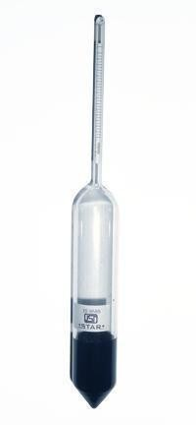

Figure 1.1 ISI Lactometer

The point up to which it sinks in the pure milk is marked after that it is put in water and is marked at the point up to which it sinks in water. It sinks less in milk than in water because milk is denser than water. The portion between ‘M’ and ‘W’ is divided into their parts and marked as 3, 2 and 1 to indicate the level of purity.

Addition of water changes speciﬁc gravity of the milk and its natural colour gets destroyed. But to compensate speciﬁc gravity, different types of salt and sugar are used. Sometimes to retain its colour a small amount of colouring matter is added. Maltodextrine are used in dairy foods to add flavour and reduce the cost of the products. Even though lactometer is generally used to measure the purity of milk, it is not a very reliable instrument. It has been observed that in the case of skimmed milk the lactometer fails to give the correct assessment of the purity if the density of the skimmed milk is made equal to that of the pure milk by adding water in an appropriate proportion.

Gerber centrifuge is used for determination of fat in milk and milk products. This centrifuge is different from other centrifuge it has provision to hold special glass tubes known as butyrometers, time adjustment clock, and rotate at fixed speeds. It has many inherent drawbacks, such as human error, multi step method, handling of corrosive chemicals and different types of glassware. All these add to the cost and time of milk testing. A quicker reliable and economical method of milk fat testing has therefor e become inevitable and an immediate problem to solve. In the light of some of problems faced by ‘GERBER’ method of testing, it was felt prudent, to evolve a systems which should solve these problems.

## LIMITATIONS OF THE CURRENT WORK

* + - Time consuming process.
    - Sensors have to be calibrated frequently.
    - User may not be familiar with the program used.
    - It wouldn’t be ideal to be used in a large scale industry.
    - The model mainly concentrates only on detection of urea.

## PROBLEM DEFINITION

Milk is considered to be the ‘ideal food’ because it is having abundant nutrients required for both infants and adults. It supplies body building proteins, bone forming minerals, health giving vitamins, minerals and furnishes energy giving lactose, milk fat and also supplying certain essential fatty acids. Milk adulteration came into global concern after breakthrough of melamine, urea contamination in Chinese infant milk products.

Unfortunately milk is being very easily adulterated throughout the world and significantly worse in developing and underdeveloped countries due to the absence of adequate monitoring and lack of proper law enforcement. Apart from the ethical and economical issue, it also creates health hazards. Most of the times, the adulteration is intentional to make greater profit, but sometimes it may be due to the lack of proper awareness. Possible reasons behind it may include- demand and supply gap, perishable nature of milk, low purchasing capability of customer and lack of suitable detection tests. Chemical adulterants are used for different purposes. The common adulterants are sugar, water, salt, starch, chlorine, hydrated lime, sodium carbonate, formalin, ammonium sulphate, H2O2 and non-milk proteins etc. To meet the deficit of milk, some people are preparing synthetic milk by mixing urea, caustic soda, refined oil and common detergents which has poisonous effect. Hence, the current review highlights the milk adulterants, their detection and their hazards on health of consumers.

## OBJECTIVES

The objective of the project is to detect the Urea content added in the milk. Also the main objective of the project is to propose a better way to detect the adulterants which is better than the existing ways. Also, the method can be developed into a hand held device such that it can be used by domestic people for identification of the urea adulteration in milk.

## METHODOLOGY

### BLOCK DIAGRAM OF PROJECT:

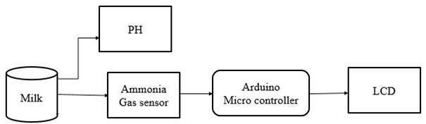

Figure 1.5.1 Block diagram of Project

The Main Block Diagram consists of 5 blocks and they are:

* + - * Milk sample block
      * Ammonia Gas Sensor block
      * Arduino Microcontroller block
      * PH Block
      * LCD block

As per the main block diagram consists of the ammonia gas sensor that is mounted on the top of the beaker which contains milk. The sensor is interfaced with the Arduino. The LCD is connected to the digital pin. The sensor detects and gives the information to Arduino and it displays the values in LCD. To heat and stir the milk the beaker is placed on the magnetic stirrer. And the computer is connected to the Arduino to upload the program. The primary sensing will be done by using the ammonia gas sensor (MQ135). This ammonia sensor detects the ammonia gas that was escaping from the gas while heating about 70 degree Celsius. The sensor will read the value and it give to the Arduino. The analog signal that was getting from the sensor will be converted to the digital values by using the Arduino board. The voltage value of the Arduino can be converted to any units by means of programming. The values can be converted to ppm by programming the Arduino. The converted signal will be displayed as a required value by using the LCD

## Hardware and Software tools used:

### HARDWARE:

a). Arduino UNO b). pH Meter

c). Gas sensor (MQ-135) d). LCD

### SOFTWARE:

* + - 1. Arduino IDE
      2. PROTEUS simulator

# Chapter 2

1. **BASIC THEORY**

Milk is a pale white liquid produced by the [mammary glands](https://en.wikipedia.org/wiki/Mammary_gland) of [mammals.](https://en.wikipedia.org/wiki/Mammal) It is the primary source of [nutrition](https://en.wikipedia.org/wiki/Nutrition) for infant mammals before they are able to [digest](https://en.wikipedia.org/wiki/Digestion) other types of food. Early- [lactation](https://en.wikipedia.org/wiki/Lactation) milk contains [colostrums,](https://en.wikipedia.org/wiki/Colostrum) which carries the mother's [antibodies](https://en.wikipedia.org/wiki/Antibody) to its young and can reduce the risk of many diseases. The principal constituents of milk constitutes of carbohydrate, fat, protein, vitamins and minerals, enzymes etc. The composition of milk varies considerably with the breed of cow, stage of lactation, feed, season of the year, and many other factors. However, some relationships between constituents are very stable and can be used to indicate whether any tampering with the milk composition has occurred.

Milk is an [emulsion](https://en.wikipedia.org/wiki/Emulsion) or [colloid](https://en.wikipedia.org/wiki/Colloid) of [butterfat](https://en.wikipedia.org/wiki/Butterfat) [globules](https://en.wikipedia.org/wiki/Butterfat) within a water-based fluid that contains dissolved carbohydrates and protein aggregates with minerals. Because it is produced as a food source for the young, all of its contents provide benefits for growth. The principal requirements are energy (lipids, lactose, and protein), biosynthesis of non-essential amino acids supplied by proteins (essential amino acids and amino groups), essential fatty acids, vitamins and inorganic elements and water.

The [pH](https://en.wikipedia.org/wiki/PH) of milk ranges from 6.5 to 6.8 and it changes over time. Milk from other [bovines](https://en.wikipedia.org/wiki/Bovines) and non-bovine [mammals](https://en.wikipedia.org/wiki/Mammals) varies in composition, but has a similar pH. Initially milk fat is secreted in the form of a fat globule surrounded by a membrane. Each fat globule is composed almost entirely of triacylglycerols and is surrounded by a membrane consisting of complex lipids such as [phospholipids,](https://en.wikipedia.org/wiki/Phospholipid) along with proteins. These act as [emulsifiers](https://en.wikipedia.org/wiki/Emulsifier) which keep the individual globules from coalescing and protect the contents of these globules from various [enzymes](https://en.wikipedia.org/wiki/Enzyme) in the fluid portion of the milk. Although 97–98% of lipids are triacylglycrols, small amounts of did and monoacylglycerols, free cholesterol and cholesterol esters, free fatty acids, and phospholipids are also present. Unlike protein and carbohydrates, fat composition in milk varies widely in the composition due to genetic, lactation, and nutritional factor difference between different species. Like composition, fat globules vary in size from less than 0.2 to about 15 [micrometers](https://en.wikipedia.org/wiki/Micrometre) in diameter between different species. Diameter may also vary between animals

within a species and at different times within a milking of a single animal. In unhomogenized cow's milk, the fat globules have an average diameter of two to four micrometers and with homogenization, average around 0.4 micrometers. The [fat-soluble](https://en.wikipedia.org/wiki/Fat-soluble) vitamins [A,](https://en.wikipedia.org/wiki/Vitamin_A) [D,](https://en.wikipedia.org/wiki/Vitamin_D) [E](https://en.wikipedia.org/wiki/Vitamin_E), and [K](https://en.wikipedia.org/wiki/Vitamin_K) along with essential fatty acids such as linoleic and linolenic acid are found within the milk fat portion of the milk. Normal bovine milk contains 30–35 grams of protein per liter of which about 80% is arranged in case[in micelles.](https://en.wikipedia.org/wiki/Micelles) Total proteins in milk represent 3.2% of its composition.

The largest structures in the fluid portion of the milk are [casein micelles](https://en.wikipedia.org/wiki/Casein) aggregates of several thousand protein molecules with superficial resemblance to a surfactant [micelle,](https://en.wikipedia.org/wiki/Micelle) bonded with the help of nanometer-scale particles of [calcium phosphate](https://en.wikipedia.org/wiki/Calcium_phosphate). Each casein micelle is roughly spherical and about a tenth of a micrometer across. There are four different types of casein proteins such as αs1-, αs2-, β-, and κ-caseins. Collectively, they make up around 76–86% of the protein in milk, by weight. Most of the casein proteins are bound into the micelles. There are several competing theories regarding the precise structure of the micelles, but they share one important feature: the outermost layer consists of strands of one type of protein, [k-casein,](https://en.wikipedia.org/wiki/K-casein) reaching out from the body of the micelle into the surrounding fluid. These kappa-casein molecules all have a negative [electrical charge](https://en.wikipedia.org/wiki/Electrical_charge) and therefore repel each other, keeping the micelles separated under normal conditions and in a stable [colloidal](https://en.wikipedia.org/wiki/Colloid) [suspension](https://en.wikipedia.org/wiki/Colloid) in the water- based surrounding fluid. Milk contains dozens of other types of proteins beside caseins and including enzymes. These other proteins are more water-soluble than caseins and do not form larger structures. Because the proteins remain suspended in [whey](https://en.wikipedia.org/wiki/Whey) remaining when caseins coagulate into curds, they are collectively known as whey proteins. Whey proteins make up approximately 20% of the protein in milk by weight. [Lacto globulin](https://en.wikipedia.org/wiki/Lactoglobulin) is the most common whey protein by a large margin.

Minerals or milk salts are traditional names for a variety of cat-ions and an-ions within bovine milk. Calcium, phosphate, magnesium, sodium, potassium, citrate, and chlorine are all included as minerals and they typically occur at concentration of 5[–4mm.](https://en.wikipedia.org/wiki/Molar_concentration#Units) The milk salts strongly interact with casein, most notably calcium phosphate. It is present in excess and often, much greater excess of solubility of solid calcium phosphate. In addition to calcium, milk is a good source of many other vitamins. Vitamins A, B6, B12, C, D, K, E, thiamine, niacin, biotin,

riboflavin, folates, and pantothenic acid are all present in milk. Milk contains several different [carbohydrate](https://en.wikipedia.org/wiki/Carbohydrate) including lactose, glucose, galactose, and other oligosaccharides. The lactose gives milk its sweet taste and contributes approximately 40% of whole cow’s milk’s calories. Lactose is a disaccharide composite of two [simple sugars, glucose](https://en.wikipedia.org/wiki/Monosaccharide) and [galactose.](https://en.wikipedia.org/wiki/Galactose) Bovine milk averages 4.8% anhydrous lactose, which amounts to about 50% of the total solids of skimmed milk. Levels of lactose are dependent upon the type of milk as other carbohydrates can be present at higher concentrations that lactose in milk.

Other components found in raw cow's milk are living [white blood cells,](https://en.wikipedia.org/wiki/White_blood_cell) mammary gland cells, various [bacteria,](https://en.wikipedia.org/wiki/Bacteria) and a large number of active enzymes. Freezing point of a solution depends on the number of particles in the solvent (water pH as of milk), rather than the kind of particles. Water without solutes will freeze at zero degrees C. The presence of any solutes will depress freezing point below zero degrees C. The freezing point of milk depends upon the concentration of water-soluble components. As milk is more diluted, the freezing point will raise closer to zero. The current official freezing point was designed for whole-herd, bulk-tank samples or processed milk samples, and not for samples from individual cows or individual quarters. The value of -

0.525 degrees Horvet is considered the upper limit which statistically is suppose to be a cut-off for most, but not absolutely all, samples to be considered water-free. However, freezing point of milk as a regulatory standard is really only valid for milk pooled form many cows (bulk tank milk). Many factors may affect freezing point of milk from individual cows. High producing cows might be expected to have higher freezing points than lower producing cows. Little work has been done in recent years to define freezing point on milk from modern high producing dairy cattle.

The boiling point of milk is close to the boiling point of water, which is 100°C or 212°F at sea level, but milk contains molecules in it, so its boiling point is slightly higher. Liquid milk is the most consumed, processed and marketed dairy product. Liquid milk includes products such as pasteurized milk, skimmed milk, standardized milk, reconstituted milk, ultra-high-temperature (UHT) milk and fortified milk. Worldwide, less and less liquid milk is consumed in its raw form. Fermented milks are commonly used to make other milk products. They are obtained from the fermentation of milk using suitable microorganisms to reach a desired level of acidity.

Condensed milk is obtained from the partial removal of water from whole or skimmed milk. Processing includes heat-treating and concentration. Condensed milk can be sweetened or unsweetened, but most is sweetened. In Latin America, for example, condensed milk is often used in cooking and baking instead of jam. Evaporated milk results from the partial removal of water from whole or skimmed milk. Processing includes heat-treating to make the milk bacteriologically safe and stable. Evaporated milk is generally mixed with other foods, such as in milky tea. Dry milk or milk powder is obtained from the dehydration of milk and is usually in the form of powder or granules.

A national survey in India has revealed that almost 70% of the milk sold and consumed in India is adulterated by contaminants such as detergent and skim milk powder, but impure water is the highest contaminant. Water is cheap and so the adulterated milk can be sold at a higher profit. Usually the adulteration will make the product more profitable, while the fraud goes undetected. Milk adulteration is a very common food fraud and is posing a big social problem in today’s world. Good-quality raw milk has to be free of debris and sediments free of off-flavors and abnormal color and odor, low in bacterial count, free of chemicals (e.g., antibiotics, detergents); and of normal composition and acidity. The quality of raw milk is the primary factor determining the quality of milk products. Good-quality milk products can be produced only from good- quality raw milk.

The hygienic quality of milk is of crucial importance in producing milk and milk products that are safe and suitable for their intended uses. To achieve this quality, good hygiene practices should be applied throughout the dairy chain. Among the causes of small-scale dairy producers’ difficulties in producing hygienic products are informal and unregulated marketing, handlings and processing of dairy products; lack of financial incentives for quality improvement; and insufficient knowledge and skills in hygienic practices.

Adulteration in milk has been a cause of concern for both the Government and the Dairy Industry. The Indian Council of Medical Research has reported that milk adulterants have hazardous health effects. The detergent in milk can cause food poisoning and other gastrointestinal complications. Its high alkaline level can also damage body tissue and destroy

proteins. Other synthetic components can cause impairments, heart problems, cancer or even death. While the immediate effect of drinking milk adulterated with urea, caustic soda and formalin is gastroenteritis, the long-term effects are far more serious.

Milk is most commonly diluted with water, it not only reduces its nutritional value, but contaminated water can also cause additional health problems. The other adulterants used are mainly detergent, foreign fat, starch, sodium hydroxide (caustic soda), sugar, urea, pond water, salt, malt dextrin, sodium carbonate, formalin, hydrogen peroxide, and ammonium sulphate. Apart from the ethical and economical issue, it also creates health hazards. Some of them are renal and skin disease, eye and heart problem and may also leads to cancer. Since quality of milk is essential for the survival of living beings on earth. Most of the times, the adulteration is intentional to make greater profit, but sometimes it may be due to the lack of proper detecting technology. Sometimes natural milk is adulterated with low value ingredient. Adulteration reduces the quality of milk also it reduces its nutritional value, and can even make it hazardous. Adulterants like soap, acid, starch, salt, table sugar and flour. Chemicals like formalin, H2O2 may be added to milk. So for preventing these, determination of milk adulteration is very important. For detection of adulterants sophisticated instrument is required. With the advancement of technology, newer techniques have been invented to detect different kinds of milk adulterants, but in the same pace the complex methods of milk adulteration and varieties of milk adulterants have been evolved. In this project quality of milk is by detecting adulterants that are added. This project mainly has four different parameters to be measured such as pH, odor, temperature and taste by the use of electronic methods of electronic nose (e-nose), electronic tongue (e-tongue), pH sensor and temperature sensor.

Milk has a pH of around 6.5 to 6.8, which makes it slightly acidic. Milk contains lactic acid, which is a hydrogen donor or proton donor. When milk is adulterated the pH value changes, variation in the pH level of the milk may cause the spoilage of the milk. Hence the quality of milk sample is tested by checking the pH level by using the pH electrode. As the milk pH changes during spoilage the voltage across the electrode varies, shifting the resonant frequency of the sensor. During a cow's milking, the milk comes out at the cow's body temperature 101.5 degrees Fahrenheit. It's quickly cooled to 36 degrees Fahrenheit. The boiling point of milk is close to the boiling point of water, which is 100°C or 212°F at sea level, but milk contains additional

molecules in it, so its boiling point is slightly higher. Milk that has been watered down contains more water and less solutes, so its freezing point is closer to 0 °C. Most milk processors will conclude that milk has been watered down if the freezing point is anywhere above -0.250

°C. When the adulterants are added to milk temperature changes and change in temperature can be detected using liquid temperature sensor.

The lactose gives milk its sweet taste and contributes approximately 40% of whole cow's milk's calories. Lactose is a disaccharide composite of two simple sugars, glucose and galactose. When milk is adulterated taste changes which can be detected using electronic tongue. An electronic tongue is a sensor which measures and compares taste of liquid or solid samples .To analyze the bacteria growth is an important task since the bacteria can cause diseases and make the milk unstable. Electronic tongue can be used to identify and recognize specific components in a solution. In this approach, experiments are conducted using an electronic tongue to virtually monitor the quality of milk.

Usually cows breathe air with a barny odor and transfer it to the milk. The concentration of odor will vary from fresh milk to adulterated milk. Dust, dirt and manure can cause an unclean flavor of milk, in addition to this when adulterants are added taste of the milk changes which can be detected by electronic nose. Electronic nose is a device intended to detect odors or flavors. It is used to crudely mimic the human olfaction and determines the aroma profile through the determination of the total profile food volatile components. It is composed of an array of non- selective sensors which transforms chemical information into an electrical or optical one such information then gets to be transformed into digital form suitable for computer processing.

Here samples of fresh milk and adulterated milk are taken, which will include fresh milk that is processed as per the standards and the samples which are contaminated due to adulteration. In general, the test will be performed with reference to standard parameter values according to which any abnormalities found in sample will be determining its quality. Depending on the pH, odor, taste and temperature values of the adulterated milk, deciding whether the given milk is good for consumption and also deciding whether the adulteration is acidic or alkaline by number of experimentations and the finally analyzing the experimented values, it is done by electronic methods.

The block diagram consists of the ammonia gas sensor that is mounted on the top of the beaker which contains milk. The sensor is interfaced with the Arduino. The LCD is connected to the digital pin. The sensor detects and gives the information to Arduino and it displays the values in LCD. To heat and stir the milk the beaker is placed on the magnetic stirrer. And the computer is connected to the Arduino to upload the program. The primary sensing will be done by using the ammonia gas sensor (MQ135). This ammonia sensor detects the ammonia gas that was escaping from the gas while heating about 70 degree Celsius. The sensor will read the value and it give to the Arduino. The analog signal that was getting from the sensor will be converted to the digital values by using the Arduino board. The voltage value of the Arduino can be converted to any units by means of programming. The values can be converted to ppm by programming the Arduino. The converted signal will be displayed as a required value by using the LCD.

Different milk samples are taken as source which includes fresh milk and adulterated milk.

## Fresh Milk:

Initially the fresh milk of about 80ml is taken in glass as sample which has the pH ranges from 6.5-6.8, temperature ranges from 30-35deg C, and also will have good odor. All the sensors in the senor block are dipped in the fresh milk sample and the corresponding test is performed. Fresh milk is as shown in figure 2.1.

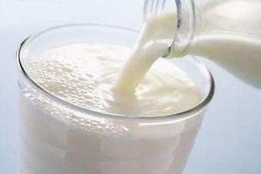

Figure 2.1 Fresh milk samples

## Adulterated Milk:

Here four types of adulterated milk sample are taken which can be the mixture of 2tbs of sugar, 40ml of water and 40ml of milk or 2tbs of salt, 40ml of water and 40ml of milk or 3/4tbs of soap,40ml of water and 40ml of milk or 2tbs of H 2O2 , 40ml of water and 40ml of milk. For each adulterated sample the sensors in the block is dipped, the sensors will detect the change in the standard reference values of pH, temperature, odor and taste and this change in parameter values will be passed to the microcontroller for further calibration. Adulterated milk is as shown in Figure 2.2.

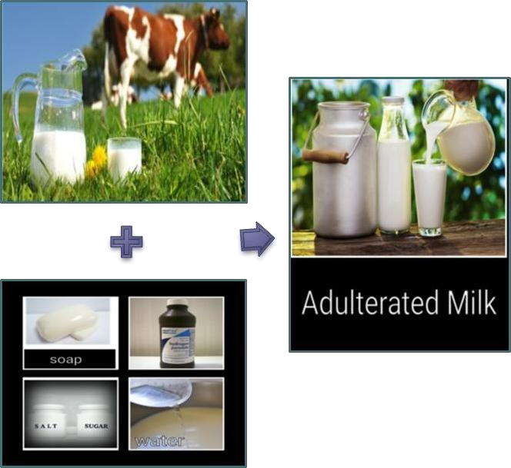

Fig 2.2 Adulterated Milk Sample

## FLOW CHART:

The following Fig 2.3 flow chart shows one of the existing method techniques to find Adulterants:

Milk sample

Milk is heated by a heater

#### NO

Check whether milk temperature is 70 °C

YES

Fig 2.3 Flow chart

The analog value in PPM is converted into digital value

The processed value is displayed through LCD

Ammonia gas is sensed by the gas sensor

# Chapter 3

1. **TOOL DESCRIPTION**

## ARDUINO IDE

Arduino is an open-source electronics platform based on easy-to-use hardware and software. Arduino boards are able to read inputs - light on a sensor, a finger on a button, or a Twitter message - and turn it into an output - activating a motor, turning on an LED, publishing something online. You can tell your board what to do by sending a set of instructions to the microcontroller on the board. To do so you use the Arduino programming language (based on Wiring), and the Arduino Software (IDE), based on Processing.

Over the years Arduino has been the brain of thousands of projects, from everyday objects to complex scientific instruments. A worldwide community of makers - students, hobbyists, artists, programmers, and professionals - has gathered around this open-source platform, their contributions have added up to an incredible amount of accessible knowledge that can be of great help to novices and experts alike.

Arduino was born at the Ivrea Interaction Design Institute as an easy tool for fast prototyping, aimed at students without a background in electronics and programming. As soon as it reached a wider community, the Arduino board started changing to adapt to new needs and challenges, differentiating its offer from simple 8-bit boards to products for IOT applications, wearable, 3D printing, and embedded environments. All Arduino boards are completely open- source, empowering users to build them independently and eventually adapt them to their particular needs. The software, too, is open-source, and it is growing through the contributions of users worldwide. Thanks to its simple and accessible user experience, Arduino has been used in thousands of different projects and applications. The Arduino software is easy-to-use for beginners, yet flexible enough for advanced users. It runs on Mac, Windows, and Linux. Teachers and students use it to build low cost scientific instruments, to prove chemistry and physics principles, or to get started with programming and robotics. Designers and architects build interactive prototypes, musicians and artists use it for installations and to experiment with

new musical instruments. Makers, of course, use it to build many of the projects exhibited at the Maker Faire, for example. Arduino is a key tool to learn new things. Anyone - children, hobbyists, artists, programmers - can start tinkering just following the step by step instructions of a kit, or sharing ideas online with other members of the Arduino community.

There are many other microcontrollers and microcontroller platforms available for physical computing. Parallax Basic Stamp, Netmedia's BX-24, Phidgets, MIT's Handy board, and many others offer similar functionality. All of these tools take the messy details of microcontroller programming and wrap it up in an easy-to-use package. Arduino also simplifies the process of working with microcontrollers, but it offers some advantage for teachers, students, and interested amateurs over other systems:

* Inexpensive - Arduino boards are relatively inexpensive compared to other microcontroller platforms. The least expensive version of the Arduino module can be assembled by hand, and even the pre-assembled Arduino modules cost less than $50
* Cross-platform - The Arduino Software (IDE) runs on Windows, Macintosh OSX, and Linux operating systems. Most microcontroller systems are limited to Windows.
* Simple, clear programming environment - The Arduino Software (IDE) is easy-to-use for beginners, yet flexible enough for advanced users to take advantage of as well. For teachers, it's conveniently based on the Processing programming environment, so students learning to program in that environment will be familiar with how the Arduino IDE works.
* Open source and extensible software - The Arduino software is published as open source tools, available for extension by experienced programmers. The language can be expanded through C++ libraries, and people wanting to understand the technical details can make the leap from Arduino to the AVR C programming language on which it's based. Similarly, you can add AVR- C code directly into your Arduino programs if you want to.
* Open source and extensible hardware - The plans of the Arduino boards are published under a Creative Commons license, so experienced circuit designers can make their own version of the module, extending it and improving it. Even relatively inexperienced users can build the [breadboard version of the module](https://www.arduino.cc/en/Main/Standalone) in order to understand how it works and save money.

# Chapter 4

1. **IMPLEMENTATION**

## HARDWARE:

### ARDUINO UNO:

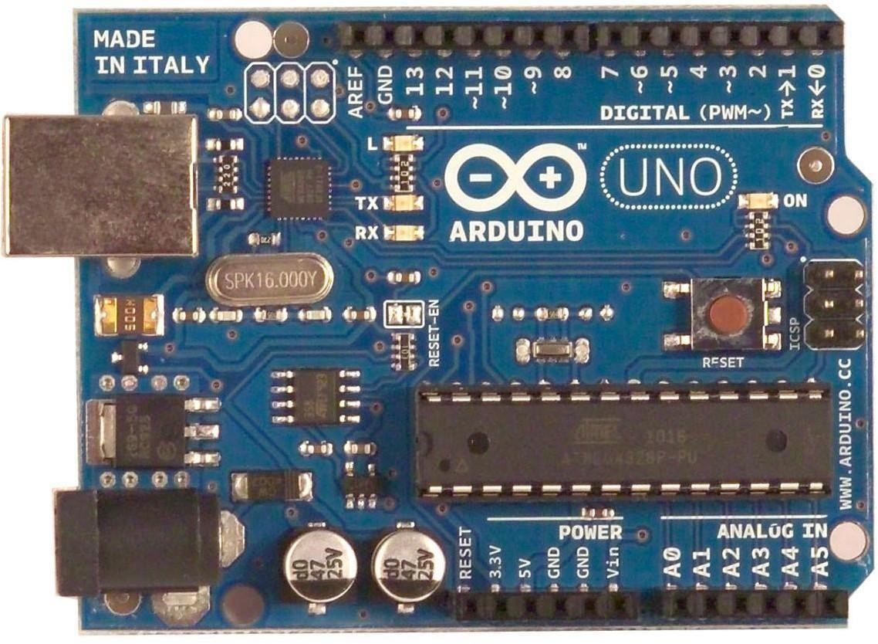

Figure 4.1.1 Arduino Uno board

Arduino is an open source computer hardware and software company, project, and user community that designs and manufactures single-board microcontrollers and microcontroller kits for building digital devices and interactive objects that can sense and control objects in the physical world. The project's products are distributed as open-source hardware and software, which are licensed under the GNU Lesser General Public License (LGPL) or the GNU General Public License (GPL), permit the manufacture of Arduino boards and software distribution by anyone.

Arduino boards are available commercially in preassembled form, or as do-it-yourself kits The boards are equipped with sets of digital and analog input/output (I/O) pins that may be interfaced to various expansion boards (shields) and other circuits .The boards feature serial communications interfaces, including Universal Serial Bus (USB) on some models, which are also used for loading programs from personal computers. The microcontrollers are typically programmed using a dialect of features from the programming languages C and C++.In addition to using traditional compiler tool chains, the Arduino project provides an integrated development environment (IDE) based on the Processing language project.

The Arduino platform has become quite popular with people just starting out with electronics, and for good reason. Unlike most previous programmable circuit boards, the Arduino does not need a separate piece of hardware (called a programmer) in order to load new code onto the board – you can simply use a USB cable. Additionally, the Arduino IDE uses a simplified version of C++, making it easier to learn to program. Finally, Arduino provides a standard form factor that breaks out the functions of the micro-controller into a more accessible.

### pH METER:

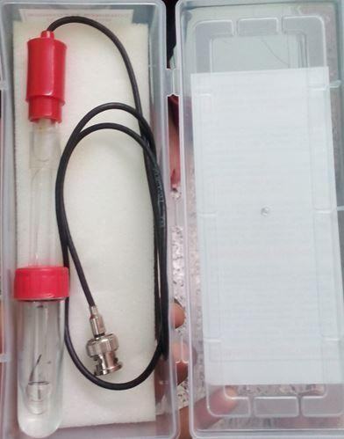

Figure 4.1.2 pH METER

The pH300 meter measures pH, mV, and temperature parameters. The built-in microprocessor provides automatic calibration, automatic temperature compensation, data storage, and self diagnostics. The meter can recognize up to 13 types of pH standard buffer solutions. The meter’s digital filter improves measurement speed and accuracy.

### AMMONIA GAS SENSOR:

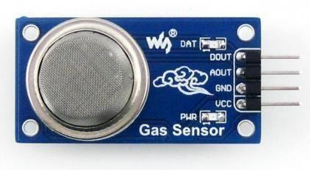

Figure 4.1.3 Ammonia gas sensor

MQ-135 gas sensor shown in figure 4.1.3 applies SnO2 which has a lower conductivity in the clear air as a gas-sensing material. In an atmosphere where there may be polluting gas, the conductivity of the gas sensor raises along with the concentration of the polluting gas increases. MQ-135 performs a good detection to smoke and other harmful gas, especially sensitive to ammonia, sulphide and benzene steam. Its ability to detect various harmful gas and lower cost make MQ-135 an ideal choice of different applications of gas detection. Structure of MQ-135 gas sensor is composed by micro AL2O3 ceramic tube, Tin Dioxide (SnO2) sensitive layer, measuring electrode and heater are fixed into a crust made by plastic and stainless steel net. The heater provides necessary work conditions for work of sensitive Component. The enveloped MQ-135 has 6 pin, 4 of them are used to fetch signals, and other 2 are used for providing heating current. Resistance value of MQ-135 is difference to various kinds and various concentration gases. So, when using this component, sensitivity adjustment is very necessary. We recommend that you calibrate the detector for 100ppm NH3 or 50ppm Alcohol concentration in air and use value of Load resistance that (RL) about 20 KΩ (10KΩ to 47 KΩ). When accurately measuring, the proper alarm point for the gas detector should be determined after considering the temperature and humidity sensor.

### LCD DISPLAY WITH I2C/LLC INTERFACE:

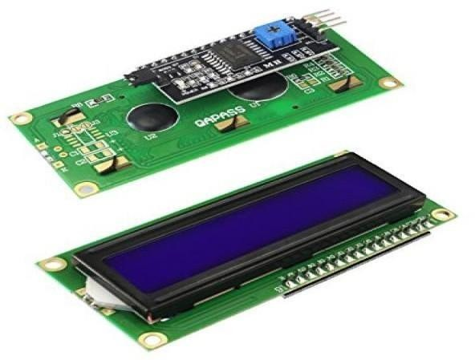

Figure 4.1.4 LCD display with I2C/LLC interface

A liquid-crystal display shown in figure 4.1.4 is a flat-panel display or other optical that uses the light-modulating properties of liquid crystals. Liquid crystals do not emit light directly, instead using a backlight or reflector to produce images in colour or monochrome. LCDs are available to display arbitrary images (as in a general-purpose computer display) or fixed images with low information content, which can be displayed or hidden, such as pre- set words, digits, and 7-segment displays, as in a digital clock. They use the same basic technology, except that arbitrary images are made up of a large number of small pixels, while other displays have larger elements. LCDs are used in a wide range of applications including computer monitors, televisions, instrument panels, aircraft cockpit displays, and indoor and outdoor signage. Small LCD screens are common in portable consumer devices such as digital cameras, watches, calculators, and mobile telephones, including smart phones. LCD screens are also used on consumer electronics products such as DVD players, video game devices and clocks. LCD screens have replaced heavy, bulky cathode ray tube (CRT) displays in nearly all applications. LCD screens are available in a wider range of screen sizes than CSEIT184522 | Published - 14 April 2018 | March-April-2018 [(4) 5: 184-191].

CRT and plasma displays, with LCD screens available in sizes ranging from tiny digital watches to huge, big-screen television sets. Since LCD screens do not use phosphors, they do not suffer image burn-in when a static image is displayed on a screen for a long time (e.g., the table frame for an aircraft schedule on an indoor sign).LCDs is, however, susceptible to image persistence. The LCD screen is more energy-efficient and can be disposed of more safely than a CRT can. Its low electrical power consumption enables it to be used in battery- powered electronic equipment more efficiently than CRTs can be. By 2008, annual sales of televisions with LCD screens exceeded sales of CRT units worldwide, and the CRT became obsolete for most purposes. The 16x2 LCD the advantages of LCD are Very compact, thin and light, especially in comparison with bulky, heavy CRT displays. Low power consumption. Depending on the set display brightness and content being displayed, the older CCFT backlit models typically use less than half of the power a CRT monitor of the same size viewing area would use, and the modern LED backlit models typically use 10–25% of the power a CRT monitor would use. Little heat emitted during operation, due to low power consumption .No geometric distortion the possible ability to have little or no flicker depending on back light technology .Usually no refresh-rate flicker, because the LCD pixels hold their state between refreshes (which are usually done at 200 Hz or faster, regardless of the input refresh rate. Can be made in large sizes of over60-inch (150 cm) diagonal .Masking effect: the LCD grid can mask the effects of spatial and grayscale quantization, creating the illusion of higher image quality. Unaffected by magnetic fields including the Earth's, as an inherently digital device, the LCD can natively display digital data from a DVI or HDMI connection without requiring conversion to analog. Some LCD panels have native fiber optic inputs in addition to DVI and HDMI. Many LCD monitors are powered by a 12 V power supply, and if built into a computer can be powered by its 12 V power supply .Can be made with very narrow frame borders, allowing multiple LCD screens to be arrayed side-by-side to make up what looks like one big screen.

## SOFTWARE ALGORITHM:

### 4.2.1 PROGRAM:

#include <LiquidCrystal_I2C.h> #include "MQ135.h"

#define ANALOGPIN A2 // Define Analog PIN on Arduino Board #define RZERO 206.85 // Define RZERO Calibration Value MQ135 gasSensor = MQ135(ANALOGPIN);

LiquidCrystal_I2C lcd(0x27, 16,2); void setup()

{

lcd.init();

lcd.begin(16,2);//Defining 16 columns and 2 rows of lcd display lcd.backlight();

Serial.begin(9600);

float rzero = gasSensor.getRZero(); delay(3000);

Serial.print("MQ135 RZERO Calibration Value : "); Serial.println(rzero);

}

void loop() {

float ppm = gasSensor.getPPM(); delay(1000);

Serial.print("AMMONIA ppm value : "); Serial.println(ppm);

lcd.setCursor(0,0);

lcd.print(" FOUND VALUE "); lcd.setCursor(0,1); lcd.print("AMMONIA : "); lcd.print(ppm); lcd.print("PPM"); }

# Chapter 5

## RESULTS AND DISCUSSION

The project consists of the ammonia gas sensor that is mounted on the top of the beaker which contains milk. The sensor is interfaced with the Arduino. The LCD is connected to the digital pin. The sensor detects and gives the information to Arduino and it displays the values in LCD. To heat and stir the milk the beaker is placed on the magnetic stirrer. And the computer is connected to the Arduino to upload the program. The primary sensing will be done by using the ammonia gas sensor (MQ135).

This ammonia sensor detects the ammonia gas that was escaping from the gas while heating about 70 degree Celsius. The sensor will read the value and it give to the Arduino. The analog signal that was getting from the sensor will be converted to the digital values by using the Arduino board. The voltage value of the Arduino can be converted to any units by means of programming. The values can be converted to ppm by programming the Arduino. The converted signal will be displayed as a required value by using the LCD.

## EXPERIMENTAL SETUP

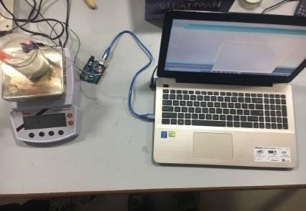

Figure 5.1 Experiment Setup of Urea Detection in Milk Using Ammonia Gas Sensor

|  |  |  |  |  |
| --- | --- | --- | --- | --- |
| **Urea(g)** | **water(ml)** | **Temperature(˚c)** | **ADC value** | **voltage** |
| 0 | 50 | 29.3 | 31 | 0 |
| 0 | 50 | 70 | 104 | 0 |
| 0.5 | 50 | 70 | 130 | 1 |
| 1 | 50 | 70 | 210 | 2 |
| 1.5 | 50 | 70 | 238 | 2 |
| 2 | 50 | 70 | 251 | 3 |
| 2.5 | 50 | 70 | 263 | 3 |

Table 5.1 Readings for urea adulterated in water

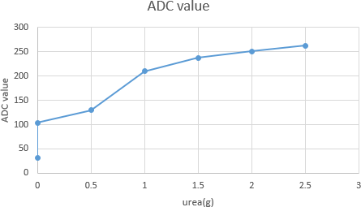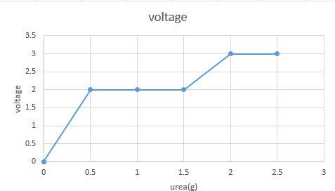

Figure 5.2 Output graph showing the results of urea adulterated in water

|  |  |  |  |  |
| --- | --- | --- | --- | --- |
| **Urea(g)** | **Milk(ml)** | **Temperature(˚c)** | **ADC value** | **voltage** |
| 0 | 50 | 29.3 | 43 | 0 |
| 0 | 50 | 70 | 113 | 0 |
| 0.5 | 50 | 70 | 135 | 1 |
| 1 | 50 | 70 | 143 | 2 |
| 1.5 | 50 | 70 | 148 | 2 |
| 2 | 50 | 70 | 156 | 2 |

Table 5.2 Readings for urea adulterated in milk

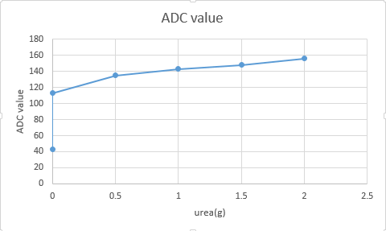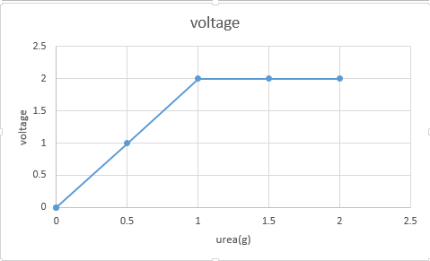

Figure 5.3 Urea adulterated in milk output graph

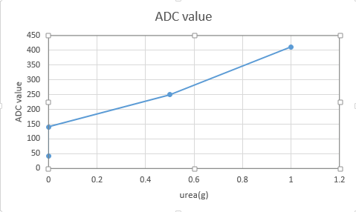 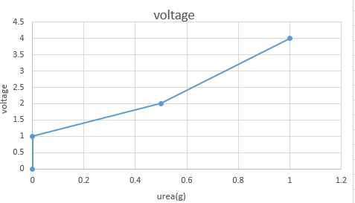

Figure 5.4 Ammonia solution adulterated in milk output graph

|  |  |  |  |  |
| --- | --- | --- | --- | --- |
| **Urea(g)** | **Milk(ml)** | **Temperature(˚c)** | **ADC value** | **voltage** |
| 0 | 50 | 29.3 | 43 | 0 |
| 0 | 50 | 70 | 113 | 0 |
| 0.5 | 50 | 70 | 135 | 1 |
| 1 | 50 | 70 | 143 | 2 |

Table 5.3 Readings for ammonia solution adulterated in milk

# CONCLUSION:

The project uses a simple gas sensor to detect the adulteration of milk for urea adulteration.. Based on the study, it is evident that only spectroscopic and chemical methods are available to detect the urea adulteration in milk. This method can detect a minimum of 2mg/lit of urea adulteration in milk at 70°C. Also, the method can be developed into a hand held device such that it can be used by domestic people for identification of the urea adulteration in milk.

# REFERENCES

* M. Simic, “Realization of complex impedance measurement system based on the integrated circuit AD5933,” in Proc. 21st Telecomm Forum (TELFOR), Nov. 2013, pp. 573–576.
* Food and Agriculture Organization of the United Nations, “Milk Processing,” FAO, 2015.
* J.-R. Riba Ruiz, T. Canals Parelló, and R. Cantero Gómez, “Comparative study of multivariate methods to identify paper finishes using infrared spectroscopy,” IEEE Trans. Instrum. Meas., vol. 61, no. 4,pp. 1029–1036, Apr. 2012.
* Santos, P. M., E. R. Pereira-Filho, and L. E. Rodriguez-Saona. "Rapid detection and quantification of milk adulteration using infrared microspectroscopy and chemometrics analysis "Food chemistry 138, no.1 (2013): 19-24
* S Das, M Sivaramakrishna, K Biswas, B Goswami (2011), Performance Study of A, Constant Phase angle Based Impedance Sensor to Detect Milk Adulteration, Sensors and ActuatorsA: Physical, 167(2), 273–27

## PROJECT PHOTOS:

**APPENDIX**

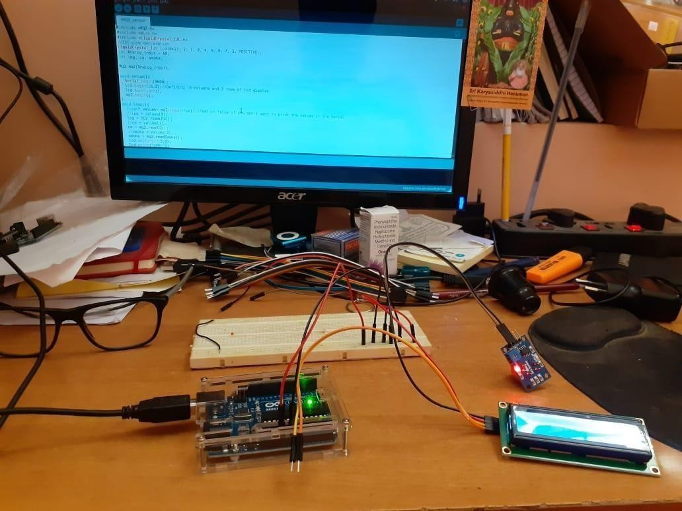

Program being burned to Arduino UNO

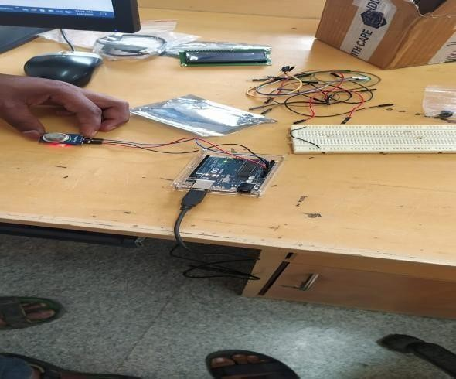

Smoke test being done in lab

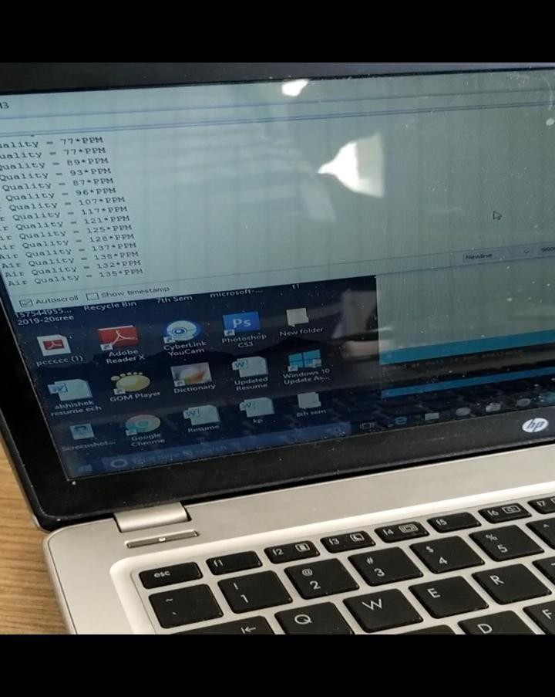

Variation of Air quality is shown in ppm.

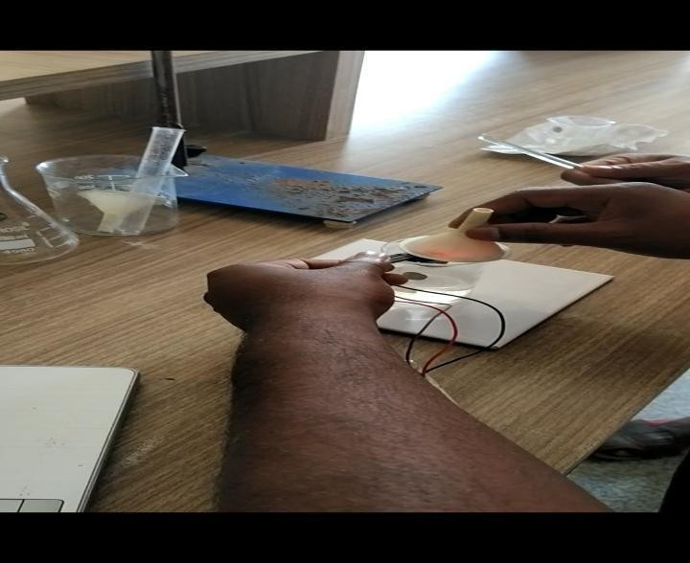

Detection of Ammonia gas from water after adding Urea content and heating it up to 70 degree Celsius.